**NAME---HARSH KUMAR**

**ID---B219027**

**BRANCH---CE-4TH SEM.**

**DATE--- 05-03-2021**

LAB-7

**1. NOT**

**List employee NOT in the dependent 10,20.**

SELECT*FROM CUSTOMER WHERE PRICE NOT IN(30000,48000,250000);

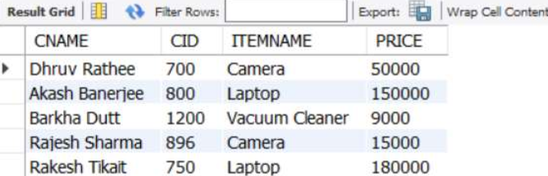

**2. Some SQL Function**

**a. Select log(2);**

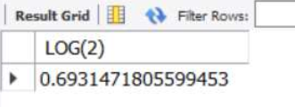

**b. Select abs(10)**

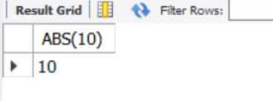

**c. Select power(2,3)**

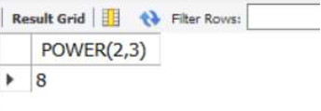

**d. Select sqrt(9)**

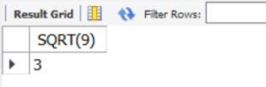

**e. Select round(12.35,1)**

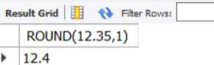

**f. Select trunc(12.35,1)**

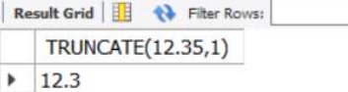

**g. Select floor(12.56)**

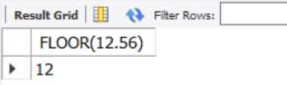

**h. Select sign(-10)**

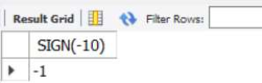

**i. Select log(3)**

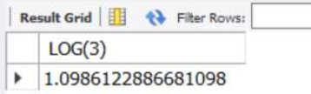

**3. Transactional Control Commands**

**Transactional control commands are only used with the DML Commands such as - INSERT, UPDATE and**

**DELETE only.**

**a. The COMMIT Command**

DELETE FROM COLLEGE WHERE CNAME= 'IIT';

COMMIT;

DELETE FROM COLLEGE WHERE LOCATION= 'Rourkela';

COMMIT;

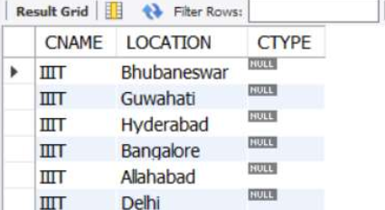

**b. The ROLLBACK Command**

INSERT INTO CUSTOMER(`CNAME`, `CID`, `ITEMNAME`, `PRICE`) VALUES

('Mamata Banerjee', '987', 'Washing Machine', '190000');

ROLLBACK;

DELETE FROM CUSTOMER WHERE CID= '750';

ROLLBACK;

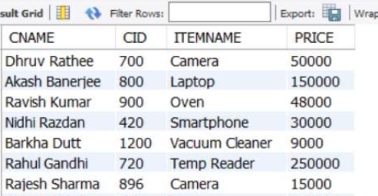

**c. The SAVEPOINT Command**

SAVEPOINT S1;

INSERT INTO PLANES(`SNO`, `NAME`) VALUES ('6', 'F14');

SAVEPOINT S2;

INSERT INTO PLANES(`SNO`, `NAME`) VALUES ('7', 'MIG35');

SAVEPOINT S3;

INSERT INTO PLANES(`SNO`, `NAME`) VALUES ('8', 'LCA TEJAS');

ROLLBACK TO S1;

**BEFORE**

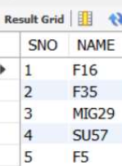

**AFTER**

